BLOOD FLOWMETER

Topic objective
By the end of the lesson the learner should be able to ;
- Explain the principle of operation and application of blood flowmeter
- Explain the principles of operation of the types of blood flowmeters
Topic Content
Introduction
Blood flow is one of the most important physiological parameters and also one of the most difficult to measure accurately. This is because instruments for measuring the flow through blood vessels within the body have to meet certain stringent specifications; e.g. sensitivity and stability requirements depend upon the magnitude of flow, location and the diameter of the individual vessels. The average velocities of blood flow vary over a wide range in vessels with diameters ranging from 2 cm to a few millimetres. Besides meeting the technical requirements, the measuring system must meet the specific clinical requirement of being the least traumatic. Blood flow measurement is thus a difficult engineering and clinical problem. It is only natural that a variety of techniques have since been developed in an effort to meet the requirements of an ideal flow metering system.
There are many widely used techniques for measuring the blood flow and velocity. They are categorized into invasive (surgical) and non-invasive (through the skin). The most accurate method, obviously, is to simply sever the vessel and time the blood flow into a calibrated beaker. But this procedure is too radical for most protocols. The most commonly used blood flow meters are described in this chapter.

ELECTROMAGNETIC BLOOD FLOWMETER

The most commonly used instrument for the measurement of blood flow is of the electromagnetic type. With this type of instrument, blood flow can be measured in intact blood vessels without cannulation and under conditions which would otherwise be impossible. However, this method requires that the blood vessel be exposed so that the flow head or the measuring probe can be put across it.
The operating principle underlying all electromagnetic type flowmeters is based upon Faraday’s law of electromagnetic induction which states that when a conductor is moved at right angles through a magnetic field in a direction at right angles both to the magnetic field and its length, an emf is induced in the conductor. In the flowmeter, an electromagnetic assembly provides

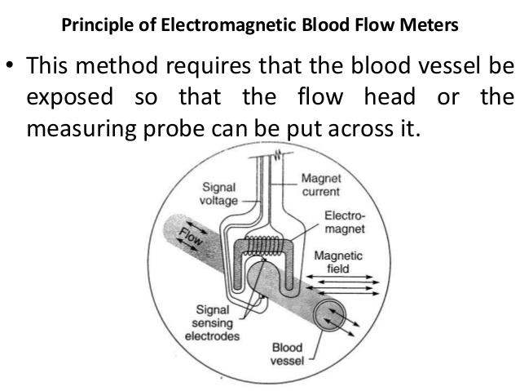

the magnetic field placed at right angles to the blood vessel in which the flow is to be measured. The blood stream, which is a conductor, cuts the magnetic field and voltage is induced in the blood stream. This induced voltage is picked up by two electrodes incorporated in the magnetic assembly. The magnitude of the voltage picked up is directly proportional to the strength of the magnetic field, the diameter of the blood vessel and the velocity of blood flow, i.e.
e = CHVd

where
e = induced voltage
H = strength of the magnetic field
v= velocity of blood flow
d = diameter of the blood vessel
C = constant of proportionality
If the strength of the magnetic field and the diameter of the blood vessel remain unchanged, then the induced voltage will be a linear function of the blood flow velocity. Therefore,
e = C1 V where C1 is a constant and equal to CHd.

Further, the flow rate Q through a tube is given by Q =VA

therefore,
V =Q/A

where A is the area of cross-section of the tube, hence e = C1 ¥ Q/A = C2 ¥ Q
where C2 is a general constant and is given by C1/A. This equation shows that the induced voltage is directly proportional to the flow rate through the blood vessel.

The induced voltage picked up by the electrodes is amplified and displayed/recorded on a suitable system. The system is calibrated in terms of volume flow as a function of the induced voltage. The diameter of the blood vessel is held constant by the circumference of the hole in the probe that surrounds it.
The above relationship is true only if there exist conditions of axial symmetry and the blood velocity is considered independent of the velocity profile. Only then, the induced voltage is directly related to the blood volume flow.
Design of the Flow Transducer: In actual practice, the electromagnetic flowmeter transducer (Wyatt, 1984) is a tube of non-magnetic material to ensure that the magnetic flux does not bypass the flowing liquid and go into the walls of the tube. The tube is made of a conducting material and generally has an insulating lining to prevent short circuiting of the induced emf. The induced emf is picked up by point electrodes made from stainless steel or platinum. The flow head contains a slot through which the intact blood vessel can be inserted to make a snug fit. Several probes of different sizes must therefore accompany the flowmeter to match the full range of sizes of the blood vessels which have various diameters. It is naturally more difficult to construct flow heads suitable for use with very small blood vessels. However, flow heads having as small as 1 mm external diameter have been reported in literature.
The flow-induced voltage of an electromagnetic flowmeter is, within certain limitations, proportional to the velocity of the flow. This velocity is the average across the flow stream with an axis symmetric velocity profile. The average flow velocity appears to be 20 to 25 cm/s in arteries and 10 to 12 cm/s in veins. For designing the probe, velocity for the cardiovascular system is taken as 15 cm/s. For non-cannulated probes, a uniform magnetic field over the measuring area is so selected that it has a convenient shape and the smallest size (Cunningham et al. 1983). Iron cored electromagnets are used in probes having a diameter between 1 to 8.2 mm, and air cored electromagnets are use in diameters above 8.2 mm. Cannulated probes for extracorporeal use can have greater field strengths and magnet size as the constraint of small size is no longer present.
To obtain a reliable recording of the flow, a certain constriction of the vessel within the probe is necessary to maintain good contact. In order to limit the amount of constriction, a 20% incremental range of sizes is chosen. To protect the probe from chemical attack, it must be encapsulated in a biologically inert material having a high electrical and chemical resistance, e.g. silicone rubber. The probes can generally be sterilized by chemical means. Probe calibration is carried out in 0.9% saline during manufacture and each probe is given a calibration factor that is engraved on the connector. This factor is set on a multi-turn potentiometer to adjust the amplification to give a full scale output on the display meter.
The transducers are usually equipped with an internal ground electrode so that no external grounding is necessary. The cable from the transducer to the instrument should comprise of a teflon insulated wire completely shielded with a tinned copper braid. The entire cable is sleeved with medical grade silicone rubber tubing and impregnated with silicone rubber to minimize leakage and electrical noise. The transducers should be tested for 1,000 megaohms minimum resistance between the coil and electrodes, after prolonged immersion in saline.
Common-mode rejection is influenced by the difference between the impedances of the pick-up electrodes of a transducer and is maximum only when these impedances are identical. Electrode impedances in saline generally lie between 1 kW and about 10 kW, values of 1.5–2 kW being typical of platinized platinum and dull gold electrodes. The common-mode impedance of the measuring circuit should be at least 100 MW to ensure that variations of several hundred ohms between the impedances of a pair of transducer electrodes do not significantly affect the common mode rejection.
The early models of electromagnetic blood flowmeters employed permanent magnets which were subsequently replaced by electromagnets powered at mains frequencies. However, the tremendous interference from mains voltages at the transducer electrodes resulted in baseline drifts and poor signal-to-noise ratio. Various types of waveforms at different frequencies have since been tried to overcome these difficulties. Today, we have electromagnetic flowmeters whose magnetic coils work on sine, square or trapezium current waveforms.
The probes have an open slot on one side which makes it possible to slip it over a blood vessel without cutting the vessel. The probe must fit the vessel during diastole so that the electrodes make good contact. Probes are made in 1 mm increments in the range of 1 to 24 mm to ensure that they can be used on a variety of sizes of arteries. The probes generally do not operate satisfactorily on veins because the electrodes do not make good contact when the vein collapses. Attempts have been made to miniaturize the flow head to an extent that it can be mounted on the tip of a catheter. Such devices are needed in experimental as well as in clinical cardiology for mapping the velocity conditions of the entire circulatory system.

TYPES OF ELECTROMAGNETIC FLOWMETERS

Basically all modern flowmeters consist of a generator of alternating current, a probe assembly, a series of capacitance coupled amplifiers, a demodulator, a dc amplifier and a suitable recording device. The shape of the energizing current waveform for the electromagnet may be sinusoidal or square.

Sine Wave Flowmeters
In a sine wave flowmeter, the probe magnet is energized with a sine wave and consequently the induced voltage will also be sinusoidal in nature. The major problem encountered with the sinusoidal type of magnetic field is that the blood vessel and the fluid contained in it act as the secondary coil of a transformer when the probe magnet is excited. As a result, in addition to the induced flow voltage, there is an induced artefact voltage generally referred to as ‘transformer voltage’.
The ‘transformer voltage’ is much larger than the signal or flow induced voltage and is 90o out of phase with it. This also causes baseline drift which necessitates high phase stability in the amplifier and demodulator circuits.
In earlier versions of sine wave flowmeters, this unwanted voltage was eliminated by injecting into the signal a voltage of equal strength, but having an opposite phase. The artefact signal is thus cancelled and only the flow induced voltage is left behind for display.
An alternative method to eliminate the transformer induced voltage in sinewave flowmeters is by using a gated amplifier. The function of this amplifier is to permit the amplification of the signals only during the portion of the cycle where flow induced voltages are maximum and the transformer induced voltages are minimum. By this method, the artefact voltage is prevented from getting amplified. This type of instrument is known as a ‘gated sine wave flowmeter’.
The sine wave flowmeters require complicated electronic circuitry for the removal of transformer induced voltage from the flow induced voltage. As both the waveforms are of the same type, complete elimination of the artefact voltage becomes extremely difficult. The sine wave system, no doubt yields good signal-to-noise ratio, but imposes stringent phase stability requirements with increasing frequency.

Square Wave Electromagnetic Flowmeters
This differs from a sine wave flowmeter in that the energizing voltage given to the magnet is a square wave and therefore, the induced voltage is also a square wave. The square wave flowmeter has less stringent requirements of phase stability than the sine wave type as it can suppress the quadrature voltages relatively easily. Also, it is easier to control the magnitude and wave shape of the energizing current in the case of a square wave system.
The transformer induced voltage in this case is only a spike, superimposed on the beginning of the square wave flow induced voltage. Separation of these two voltages becomes easier as the amplifier can be gated only for a very short period. In a square wave flowmeter, blanking is required only during the portion when the current in the magnet is reversing and the amplifier works during the flat portion of the square wave. The square wave is amplitude modulated by the variation in blood flow and requires to be demodulated before it can be fed to a recorder.

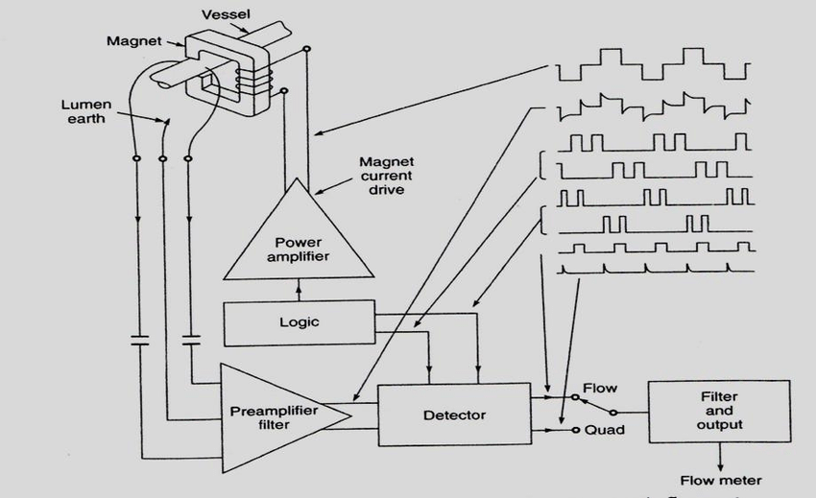

Block diagram of a square wave electromagnetic blood flowmeter.

Transducer: The flow transducer consists of an electromagnet, which provides a magnetic field perpendicular to the direction of flow and lying within the field are a pair of pick-up electrodes whose axis is perpendicular to both the field and the flow axis. The electrodes may be in contact with either the flowing blood or the outer surface of the blood vessel carrying the flowing blood. The former is called ‘Cannulating flowmeter’ and the latter ‘Cuff flowmeter’.
Preamplifier:
The induced voltage picked up by the electrodes is given to a low noise differential amplifier through a capacitive coupling. The preamplifier must have a very high common-mode rejection ratio and input impedance. The preamplifier used by Goodman (1969(a)) has a CMRR of 106 dB (200,000 : 1) with a common mode input impedance of 150 MW. The preamplifier gain is of the order of 1000. The preamplifier also must incorporate the facility for ‘probe balance’ by which signals in phase with the magnet current can be selected to balance background voltages in phase with flow voltages. A calibrating signal of 30 mV amplitude can be connected to the preamplifier with an input selector switch.
Noise voltage generated in the preamplifier is an important factor in the performance of an electromagnetic flowmeter. The noise voltage is seen as a random movement of the baseline of the recorded flow. When expressed in terms of flow, it is typically 1–2% of the full scale output of the chosen probe. For example, a 2.7 mm probe gives full scale deflection for 500 ml/min, so the noise is equivalent to 10 ml/min.
Gating Circuit: A gating amplifier helps to remove spurious voltages generated during magnet current reversal. For the flowmeter to exhibit a satisfactory base line stability, it is essential that the spurious signals produced during the magnet current reversal and those in phase with flow voltages are made negligible. The gating action is controlled by the circuit which provides an excitation current to the electromagnet.
Bandpass Amplifier: Following the gating amplifier is an active RC bandpass amplifier, which selectively passes through it the amplified square wave signal. The peak response is kept for 400 Hz. The 3 dB points are at 300 and 500 Hz. The gain of this amplifier is typically 50. The shape of the wave after this amplifier is a distorted sinusoid.
Detector:
A phase sensitive detector is used to recover the signal, which is an analogue of the flow rate being measured. This type of demodulator not only offers maximum signal-to-noise ratio but also helps in the rejection of interfering voltages at frequencies well below the carrier frequency.
Low-Pass Filter and Output Stage:
The demodulated signal is given to an active RC low-pass filter, which provides a uniform frequency response and a linear phase shift from 0–30 Hz. This is followed by an integrator circuit to provide an output corresponding to the mean flow. The output signal thus obtained can be put to a recorder to read the blood flow rate from the calibrated scale.
Magnet Current Drive:
The excitation current supplied to the electromagnet is a one ampere peak square wave current. It is given from a source of high impedance to ensure that it remains constant for variations in magnet winding resistance of up to 5 W. The square wave input to the power amplifier stage which supplies current to the electromagnet is fed from a free running multi-vibrator working at 400 Hz.
Zero-Flow Reference Line:
Before measurement can be made for blood flow with electromagnetic flowmeters, it is essential to accurately establish the signal corresponding to zero-flow. Although de-energizing the magnet should produce a zero reference line, unfortunately this line does not always coincide with the physiological zero-flow line. This is owing to some effects at the electrode vessel interface. An alternative method could be to occlude the blood vessel in which flow is to be measured. Several arrangements have been used to act as occluders (Jacobson and Swan, 1966). However, there is a serious objection to their use because the necessity for occlusion of the vessel, in order to obtain a zero flow reference, introduces the possibility of producing a spasm and hence a change in the blood flow.

ULTRASONIC BLOOD FLOWMETERS
There are basically two types of ultrasonic blood flow-velocity meters. The first type is the transit-time velocity meter and the second is the Doppler-shift type. For routine clinical measurements, the transcutaneous Doppler instrument has, by far, superseded the transit-time type. Therefore, most of the recent efforts have been concentrated on the development of Doppler-shift instruments, which are now available for the measurement of blood velocity, volume flow, flow direction, flow profile and to visualize the internal lumen of a blood vessel.

Doppler-shift Flow-velocity Meters
It is a non-invasive technique to measure blood velocity in a particular vessel from the surface of the body. It is based on the analysis of echo signals from the erythrocytes in the vascular structures. Because of the Doppler effect, the frequency of these echo signals changes relative to the frequency which the probe transmits. The Doppler frequency shift is a measure of the size and direction of the flow velocity. The principle is illustrated in Fig. 10.4. The incident ultrasound is scattered by the blood cells and the scattered wave is received by the second transducer. The frequency shift due to the moving scatterers is proportional to the velocity of the scatterers. Alteration in frequency occurs first as the ultrasound arrives at the ‘scatterer’ and second as it leaves the scatterer. If the blood is moving towards the transmitter, the apparent frequency f1 is given by

f1 = (C - v cos q )
where f = transmitted frequency
v= velocity of sound in blood
q= angle of inclination of the incident wave to the direction of blood flow v = velocity of blood cells

After manipulation,
v = 2 f cos q

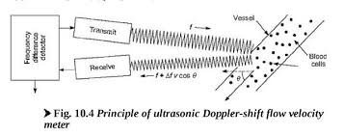

This relationship forms the basis of measuring blood velocity. Depending on the application, either a signal proportional to the average instantaneous velocity or a signal proportional to the peak instantaneous velocity may be required. The peak signal is easier to obtain and has been shown to be of particular importance in localizing and quantifying the severity of peripheral vascular diseases (Johnston et al, 1978).
In order to measure absolute velocity, the angle of inclination of the ultrasonic beam to the direction of flow must be known. Several methods are available for doing so. The first uses the principle that the Doppler shift signal is zero when the ultrasonic beam is at right angles to the direction of flow. So, by finding the position of the zero Doppler signal with the probe over the vessel and then by moving it through a known angle of inclination, the angle becomes known. However, due to the separation of the transmitter and receiver, the Doppler shift frequencies are not zero. In such cases, the position at which the minimum Doppler shift frequencies are present is taken for the probe to be at right angles.
The early instruments used a continuous wave (CW) ultrasonic beam. Basically, a CW ultrasonic Doppler technique instrument works by transmitting a beam of high frequency ultrasound 3–10 MHz towards the vessel of interest. A highly loaded lead zirconate titanate transducer is usually used for this purpose. The transducer size may range from 1 or 2 mm to as large as 2 cm or more. A separate element is used to detect the ultrasound back scattered from the moving blood. The back-scattered signal is Doppler shifted by an amount determined by the velocity of the scatterers moving through the sound field. Since the velocity varies with the vessel diameter to form a velocity profile, the returned signal will produce a spectrum corresponding to these velocities.
Flax et al (1973) discuss the circuit of the Doppler ultrasonic blood flowmeter. The piezo-electric crystal A is electrically excited to generate ultrasonic waves, which enter the blood. Ultrasound scattered from the moving blood cells excites the receiver crystal. The electrical signal received at B consists of a large amplitude excitation frequency component, which is directly coupled from the transmitter to the receiver, plus a very small amplitude Doppler-shifted component scattered from the blood cells. The detector produces a sum of the difference of the frequencies at D. The low-pass filter selects the difference frequency, resulting in audio frequencies at E. Each time the audio wave crosses the zero axis, a pulse appears at G. The filtered output level at H will be proportional to the blood velocity. The
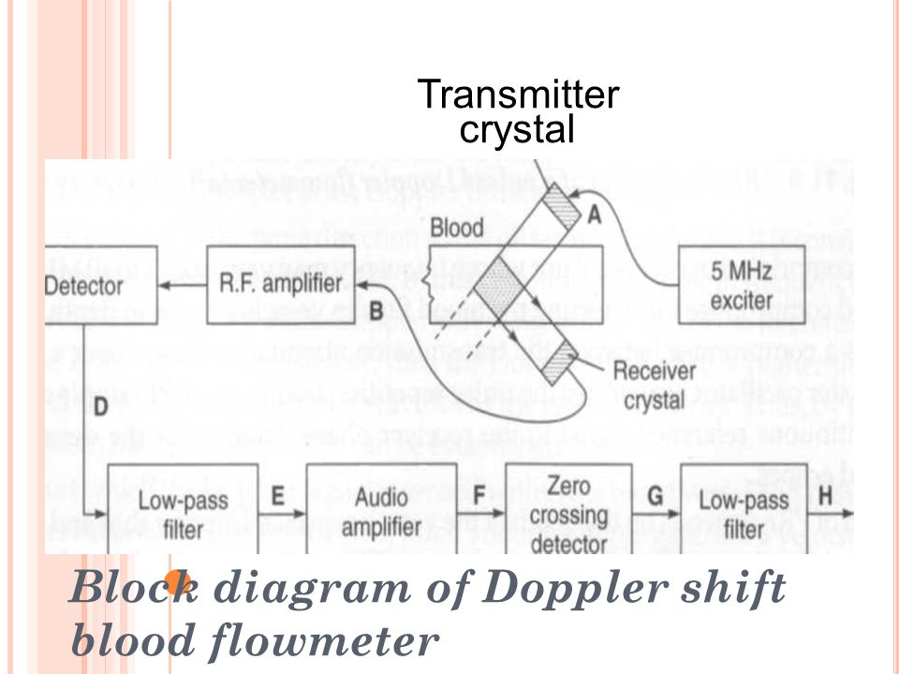

following two pitfalls are encountered in Doppler ultrasonic blood flowmeters. High frequency response is usually inadequate which introduces a non-linearity into the input-output calibration curve. Also, the low frequency gain is normally too high, resulting in wall motion artefacts. The maximum Doppler shift has been calculated as about 15 kHz. The wall motion signal can be significantly reduced by filtering out frequencies below 100 Hz.

Range gated Pulsed Doppler Flowmeters
Instruments based on a CW Doppler can be better characterized as flow detectors rather than flowmeters. Even a simple measurement of the mean flow velocity requires that the angle between the sound beam and the velocity vector should be known. Baker (1970) states that recordings in literature that are calibrated in terms of Doppler frequency shift are both misleading and frequently inaccurate. The investigators did not or could not make the angle measurement required to quantify their data. Many of the difficulties associated with the CW system can be overcome if the ultrasonic source is pulsed and the Doppler shift of the returning echo is determined. If the return signal is range gated, then the distance to the moving interface (blood vessel diameter) as well as its velocity with respect to the beam can be measured.
Transmitter:
It comprises a master oscillator whose frequency may vary from 2 to 10 MHz; however 5 MHz is a good compromise for detecting the blood flow in vessels 4-6 cms in depth. The choice of frequency is a compromise between the transmission attenuation losses over a given path length. The master oscillator also drives the pulse repetition frequency (PRF) ripple counter and provides a continuous reference signal to the receiver phase detector for the detection of the Doppler-shifted echoes.
The selection of PRF depends on the depth of the vessel, expected Doppler shift and attenuation characteristics of the tissue. The following values of PRFs and range depth combinations for optimum results have been suggested:
The PRF pulse triggers a 1 ms one shot multi-vibrator that generates the gating signal. When the gate opens, 5 cycles of the master oscillator pass through to a power amplifier. The peak power output applied to the transmitting transducer is in the range of 10 to 30 W during the 1 ms excitation burst. With the PRF of 25 kHz, the average power applied to the transducer ranges from 0.25 to 0.75 W depending on the transducer impedance, which may be 50 to 200 W. The radiating area of the transducer ranges from 0.5 to 2 cm2.
The transducers for pulsed Doppler applications should ideally have the sensitivity of the lightly backed narrow-band CW Doppler units and the wide bandwidth of the pulse echo units. The Q of transducers designed for CW applications ranges from 10 to 30 or more. These transducers ring at their resonant frequency long after the electrical signal stops. Pulse echo-transducers use tungsten epoxy backing to have a Q as low as 1.5–2.5. However, the Q is not lowered to a desirable value of about 1.5 to 5 because this would greatly decrease both the efficiency of the transmission and the sensitivity of the reception. The Q of pulsed
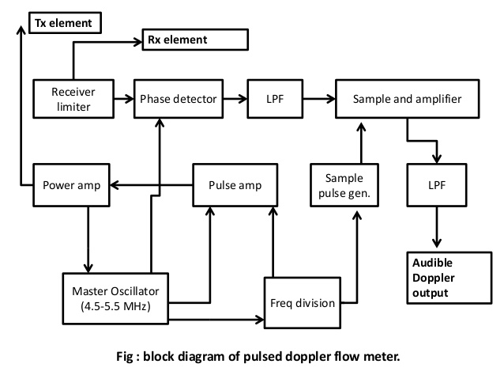

Doppler transducers is generally kept at 5 to 15 and some ringing is thus tolerated. These transducers have a backing of aluminium powder in epoxy.
Receiver:
The back-scattered Doppler-shifted signals from a blood vessel range in intensity from 50 dB to more than 120 dB down from the transmitted signal. The receivers designed for this purpose have a bandwidth of 3 MHz and gain in excess of 80 dB. This is followed by a single side band type quadrature phase detector which separates the upper and lower Doppler side bands for sensing flow direction. The detector consists of a phase-shift network, which splits the carrier into two components that are in quadrature, which means they are 90°. These reference cosine and sine waves must be several times larger than the RF amplifier output. The Doppler shift of the received echo, back scattered by the moving blood is detected by sensing the instantaneous phase difference between the echo and a reference signal from the master oscillator. If the echo at a particular range or depth contains a Doppler-shift, then the amplitude of a sample of the instantaneous phase difference will vary in amplitude exactly with the Doppler difference frequency. The envelope frequency from the phase detector is the Doppler difference frequency.
If the flow of blood is in the same direction as the ultrasonic beam, then it is considered that the blood is flowing away from the transducer. In this case, the Doppler-shift frequency is lower than that of the carrier and the phase of the Doppler wave lags behind that of the reference carrier. If the flow of blood is towards the transducer, then the Doppler frequency is higher than the carrier frequency and the phase of the Doppler wave leads the reference carrier. Thus, by examining the sign of the phase, the direction of flow can be established.
The depth at which the Doppler signal is sensed within the blood vessel and tissue depends on the delay interval between the transmitted burst and the sample gate. For a velocity of sound, in tissue of approximately 1500 m/s, the range factor is 13.3 ms delay/cm of depth. A one-shot multi-vibrator is used to develop the adjustable range delay calibrated in millimetres of depth. This is followed by a ‘sample gate’. The detected Doppler shift frequency will correspond to the mean velocity averaged over the sample volume. However, the Doppler signals at the output of the sample and hold circuit are low in amplitude and contain frequency components from the transmitter pulse repetition rate and the low frequency large amplitude signals produced by the motion of interfaces such as vessel walls and the myocardium. Therefore, both high-pass and low-pass filters are used to extract the signals of interest. Once the signals are filtered with a passband of 100 Hz to 5 kHz, it is further amplified to drive an external audio amplifier or a frequency meter.
Zero-crossing Detectors:
In order to measure blood velocity, a frequency meter is needed to analyze the frequency components of the Doppler signal. Nearly all Doppler velocimeters use zero-crossing detectors for this purpose. The function of the zero-crossing detector is to convert the audio frequency amplifier output to a proportional analog output signal. It does this by emitting a constant area pulse for each crossing of the zero axis from negative to positive. The output of the zero-crossing detector is a series of pulses. These pulses are passed through a low-pass filter to remove the high frequency component. The filter pass frequencies from 0 to 25 Hz in order to reproduce the frequencies of interest in the flow pulse. The zero-crossing detector is capable of measuring blood velocity to within 20% and can detect changes in velocity of about 5%. A major limitation of the zero-crossing detector used in simple flowmeters is that it cannot detect the direction of flow. A better approach is to use the quadrature-phase detector approach, which is commonly used in radar technology. This detector gives not only the velocity with which the blood flows but also its direction.

Spectrum Analyzers:
Because of the limitations of the zero-crossing detector, alternative methods have been employed for the analysis of Doppler signals for velocity measurements. For example, spectrum analyzers are used to derive blood flow velocity information from Doppler signals. A spectrum analyzer processes short lengths of audio signal to produce spectral displays, which have frequency as the abscissa, time as the ordinate and spectral intensity represented by record darkening.
Spectral analysis of Doppler signals with a spectrum analzser is an off-line technique. The process of obtaining a good record involves aural recognition of the relevant Doppler wave forms, the recording of these on tape and the subsequent analysis of short sections at a time. In order to study effects extending over several cardiac cycles and also to allow the operator to optimize the recording during clinical investigation, a real-time continuous form of analysis is needed. Macpherson et al (1980) describe a real-time spectrum analyzer for ultrasonic Doppler signals. The analyser calculates spectral components using a type of Discrete Fourier Transform (DFT) known as the Chirp-Z-Transform.
Development of a real-time system for the three dimensional display of Doppler-shifted frequencies within an ultrasound flowmeter signal is described by Rittgers et al (1980). The device is based on a Fast Fourier Transform (FFT) spectrum analyzer, which provides both high frequency and time resolution over a variable range of frequencies up to 40 kHz. Signal pre-processing filters out unwanted low frequency artefacts due to arterial wall motion and automatically controls input gain to limit peak amplitudes while matched phase shift networks translate forward and reverse components for a directional output.
Ultrasound directional Doppler blood-velocity detection may be achieved using any of the three basic detection systems. These are single sideband, heterodyne and phase-quadrature
detection systems. Out of these, phase-quadrature detection system is the most commonly used. Phase-quadrature detection systems operate by detecting both the amplitude and phase of the Doppler-shifted frequency.
Schlindwein et al (1988) used a digital signal processor chip to perform the online spectrum analysis of the Doppler ultrasound signals. It is a flexible and a programmable method, which has every aspect of the system such as window function, frequency ranges and the transform rate under software control.

NMR BLOOD FLOWMETER

Nuclear magnetic resonance principle offers yet another non-invasive method for the measurement of peripheral blood flow or blood flow in various organs. The method pertains to a quantum mechanical phenomenon related to the magnetic energy levels of the nucleus of some elements and their isotopes. For blood flow measurement work, behaviour of the two hydrogen atoms of water is studied, since blood is approximately 83% water. Due to the magnetic moment of the hydrogen atom, the nucleus behaves as a microminiature magnet which can be affected by externally applied magnetic fields. The hydrogen nuclei orient themselves to produce a net parallel alignment to a steady magnetic field. The nuclear magnets precess around the magnetic field lines until they become aligned. The angular frequency (Larmor frequency) of this precession is given by

v = r Bo

where r is the ratio of the magnetic moment to the angular momentum (the magnetic gyro ratio) and Bo is the density of the steady magnetic field and v is the frequency of radiation.
When the frequency of the magnetic field is near the Larmor frequency, the nuclear magnets can be rotated and their presence detected secondary to an externally applied radio frequency magnetic field. Also, a region of demagnetization can be made by disorienting the nuclear magnets with a radio frequency field very close to the Larmor frequency.
An arrangement for the measurement of blood flow using the NMR technique is shown below .The blood vessel of interest is positioned in a uniform steady magnetic field Bo. The nuclear magnets of the hydrogen atoms, which before insertion were randomly oriented, now begin to align themselves with Bo. Some begin to align parallel, whereas others commence to align anti-parallel. The alignment occurs exponentially with a time constant T1 known as the longitudinal relaxation time. There are more nuclear magnets aligned parallel to Bo in contrast to those aligned anti-parallel. For blood at 37°C, there are 0.553 ¥ 1023 hydrogen nuclei per litre.
Arrangement for measurement of arterial blood flow using NMR principle. Hydrogen nuclei in the blood are magnetised by the magnetiser Bo. The nulcei are detected downstream by the receiver coil millilitre. For Bo = 1000 gauss, there are 1.82 ¥ 1016 per millilitre net nuclei aligned. The maximum magnetization Mo due to the magnetic field Bo is given by Mo = Xo Bo, where Xo is the static nuclear magnetic susceptibility equal to 3.23 ¥ 10–9 for blood at 37°C. Thus for Bo = 1000 gauss, Mo = 3.23 microgauss.
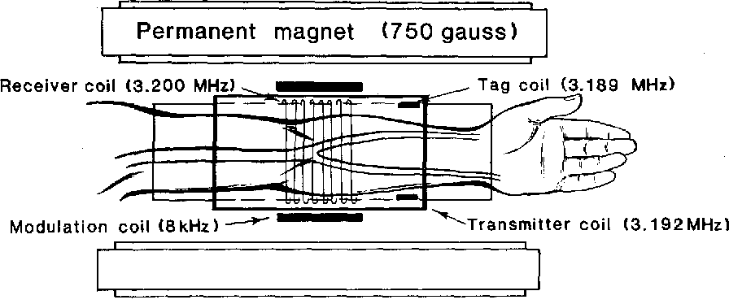
The magnitude of the magnetization can be related to either flow velocity or flow rate. Since the magnetization can be changed at some point in a magnetic field, and the change detected at some distal point, it is possible to determine the transport time between the two points. A crossed coil configuration is used to detect the level of magnetization in the limb. Two magnets are used, a strong permanent magnet Bo for premagnetization and a weaker, homogeneous electromagnet BD for detection. A graph plotted between the magnetization at the centre of the receiver coil for typical distances as a function of velocity shows that the magnetization changes proportionally to velocity and thus a measurement of the magnetization can yield velocity information. If a receiver coil is used, the voltage induced in the coil by the magnetization is proportional to the cross-sectional area of the vessel carrying the blood. The NMR signal voltage proportional to velocity V, and multiplied by area A, will give a volumetric flow rate Q. With a homogeneous detector field BD, the magnetization in all the blood vessels in the region is detected. In a non-homogeneous field, BD can be tuned to detect the magnetization of selected vessels. The major shortcoming of NMR blood flowmeters is the physical size of the magnets and the sensitivity of the system needed to detect the magnetically tagged bolus of blood.

For the measurement of arterial blood flow, the blood in the upper arm is magnetized by the niagnetizer BO and the magnetized blood is detected in the forearm by the receiving coil. The NMR signal waveform will be pulsatile because the arterial flow is pulsatile. For venous flow measurement, the arm is inserted in an opposite direction. Since venous flow is relatively steady, the magnetization at the receiver coil is also steady. For cerebral flow studies, a 78 cm wide, 45 cm high, 44 cm deep permanent magnet system of 540 gauss field is used. The size is large enough to accommodate a human head. NMR based flowmeters are limited in their applications to the measurement of blood flow in limbs, since the part of the body to be measured must be located inside the lumen of a cylinder.

END

